Game Design Document Try-Guys

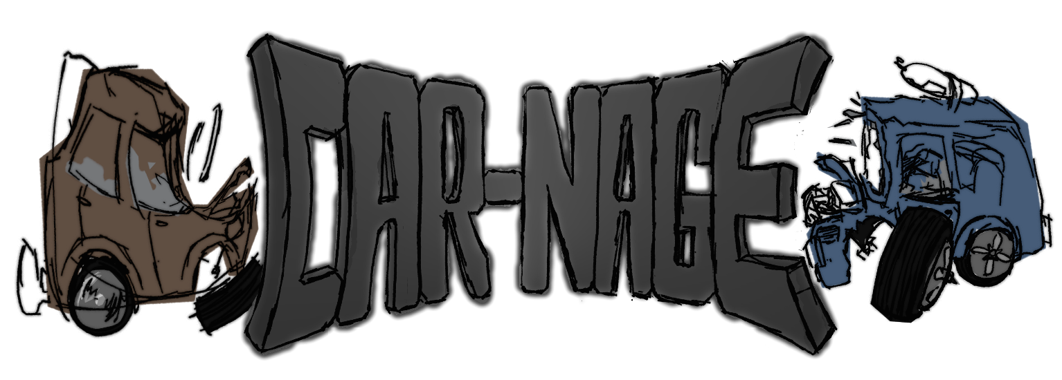

|  |  |  |  |
| --- | --- | --- | --- |
| Revision List | | | |
| Version | Author | Date | Comments |
| 0.1 | Andrew Scott | 24/09/2019 | Draft document |
| 0.2 | Tembani Mdaya and Thomas Riches | 24/09/2019 | Filled out multiple sections of the document. |
| 0.3 | Thomas Riches | 1/10/2019 | Changed a little bit about how the player controls their player character. |
| 0.4 | Andrew Scott & Tembani Mdaya | 1/10/2019 | Created enemies section under gameplay, Wrote something for Overview, Game Concept and Game Features. |
| 0.5 | Andrew Scott | 15/10/2019 | Amended some sections and added to game fetchers. |
| 0.6 | Tembani Mdaya, Andrew Scott and Thomas Riches | 22/10/2019 | Changed the logo in the cover to a more current version. Added more to Story, Enemies and different version of controls. Added map design section and flow chart diagrams. |
|  |  |  |  |
|  |  |  |  |

Table of Contents

Introduction 3

Refrences 3

Platform and Software 3

Game Specification 3

Game Concept 3

Story/setting 4

Game Features 4

objective 4

Graphics 4

Gameplay 4

overview 4

scaling difficulty 4

score system 5

Controls 5

combat 5

Enemies 5

flowchart 5

Interface 6

Menu 6

Hud 6

camera 6

Team 6

Appendices 6

asset list 6

# Introduction

The game we are going to create is a 2.5D arena survival with cars similar to demolition derby but is set in a similar vain to Mad Max. The game is set in a post-apocalyptic wasteland where different clans of people compete in a demolition derby against each other for glory and bragging rights. The player takes the helm as a combatant fighting for survival in an arena attempting to survive. The game will incorporate elements similar to games like “Move or Die” “Risk of Rain” and “Mad Max”.

## Refrences

[(cargo ship)](https://image.shutterstock.com/z/stock-photo-cargo-ship-covered-with-rust-on-a-beach-near-gythio-greece-238115122.jpg)

<https://github.com/Tri-Guys>

# Platform and Software

The game will be developed for use with either a keyboard or a controller on Windows, but could be made to work for mobiles and tablets. The game will be developed in the Unity game engine using a 2.5D environment as the team has more experience with Unity than the Unreal Engine.

# Game Specification

## Game Concept

The game will be a high-octane, fast-paced 2.5D Beat-Em-Up game set in a post-apocalyptic world where rules are no more. The player sets out on the Road as a search for fuel because he is constantly losing it on the go, but he is only later confronted with scavengers and baddies looking forward in taking the player down. Luckily, his car has a special absorb power to counter its terrible fuel usage and is able to gain fuel from defeating the enemy cars in front of them.

## Story/setting

A bleak destroyed future where the sky accumulated the look of the sewers.

The aftermath of failed peace treaty signing leading to the horrid beginning of a new civilisation. World Order has been pushed off its’ balance, thus leaving the remaining humans to unleash their animal spirit.  
You are wake up smelling the same burnt oil and spilt fuel and realise that you are running out in your home so you have to take on the outside and find the nearest fuel station that’s still functioning, the nearest one just so happens to be situated near a destroyed shipping port.  
The tough part is getting past hordes of enemies who want nothing else than scorching destruction, so you’ll just have to fight past them.

Welcome to the Desert.

## Game Features

In most beat-em-up games, you never have the option to do quick dodges from enemy attacks in any direction so we are looking to implement a “Juke” sort of feature.

The game will have a sort of timer that acts as the players fuel and life, over time it will drain and being hit with attacks will take a chunk off it but it can be refilled with fuel containers.

The game will also feature the traditional power-ups and pick-ups such as;  
Flimsy Fuel Cap – Stops Fuel/Health Drain for X seconds  
Piercing Plates – Increases Ramming damage  
General Guns – Piston, Shotgun, Machine Gun, Rocket Launcher etc  
Desert Diesel – Increases Speed for X seconds

## objective

In the current state of the game, the objective is to simply survive for as long as possible, accumulating high scores by defeating and outliving the enemy. The game will inevitably end when the difficulty becomes too great to overcome.

## Graphics

The graphics will be a mix of 2D and 3D, where the sprites are 2D but the background will have depth.

# Gameplay

## overview

The gameplay will be in the style of an arcade, side-scroller, beat-em-up game. The player will be against a small horde of enemies in front of them and the player has to clear the screen before they are able to proceed.

## scaling difficulty

Over time, the player will fight increasing odds. This comes in two forms: lifetime progression where the difficulty will slowly ram up the threat in a natural manner introducing more enemies and extra enemy types, and power progression where finding and equipping a weapon will provoke a specific enemy type – a Flyer for example – to come out to match how dangerous you are. Flyers themselves cannot be rammed into and must be shot down, giving their appearance more weight – you cannot attack them without a gun.

## score system

A scoring system will be put into play and displayed on the player’s screen. Their personal score will increase over their lifetime and will receive a boost when an enemy has been destroyed. A multiplier will kick it once at least three enemies have been dispatched.

## Controls

The player will use the WASD keys to control a car around the map, the space bar to attack and the number keys to select weapons.

The player will use the WASD keys to control the car around the area.  
The Spacebar will be used for dodging/juking attacks from enemies  
The J Key will be used for a normal attack.  
The K Key will be used for a heavy attack which will consume some fuel.  
The L Key will be used for some of the pickups (Pistol, Shotgun, etc)

## combat

Car combat will rely on a mix of aggressive ramming and high-power weaponry. Ramming is an option that is always available to the player and depends running straight into an enemy to perform. Weapons however must be found and collected to use and have a limited amount of ammunition; once the player’s magazine is empty the player will have to find an ammo box that sometimes drops from enemies to use the gun again. Shooting cannot be used without a gun.

## Enemies

Normal Type: Just like the player’s car, nothing much special about it.  
  
Fast Type: This car is a lot faster than the players but it’s also a lot weaker. You will need to focus on dodging their attacks before you can land yours.  
  
Brute Type: A big construction vehicles modified to deal as much damage as possible without leaving any trace, all at the price of speed. A real risky enemy as it takes time to attack leaving you a big window for multiple blows, but if you are too greedy, you will face a huge hit leaving close to exploding.  
  
Hoverboard: A special vehicle made to fly over the enemy, dropping harmful things to the enemy. Built just like a battleship but for land instead

## Map Design

The design of the map resembles a destroyed ship port made into a cobbled together arena made from bits of rusted scrap, cargo containers and cargo ship with the remains of the cargo ship still in its port. We decided on this design as it reinforces the post-apocalyptic setting the game takes place in. This also allows us to scatter obstacles throughout the arena to give the player some difficulty navigating the map and to enforce the aesthetic of the ship being picked apart for parts.

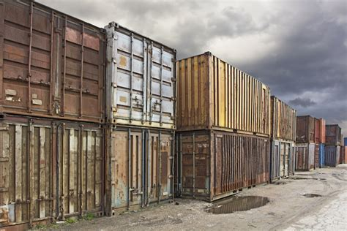  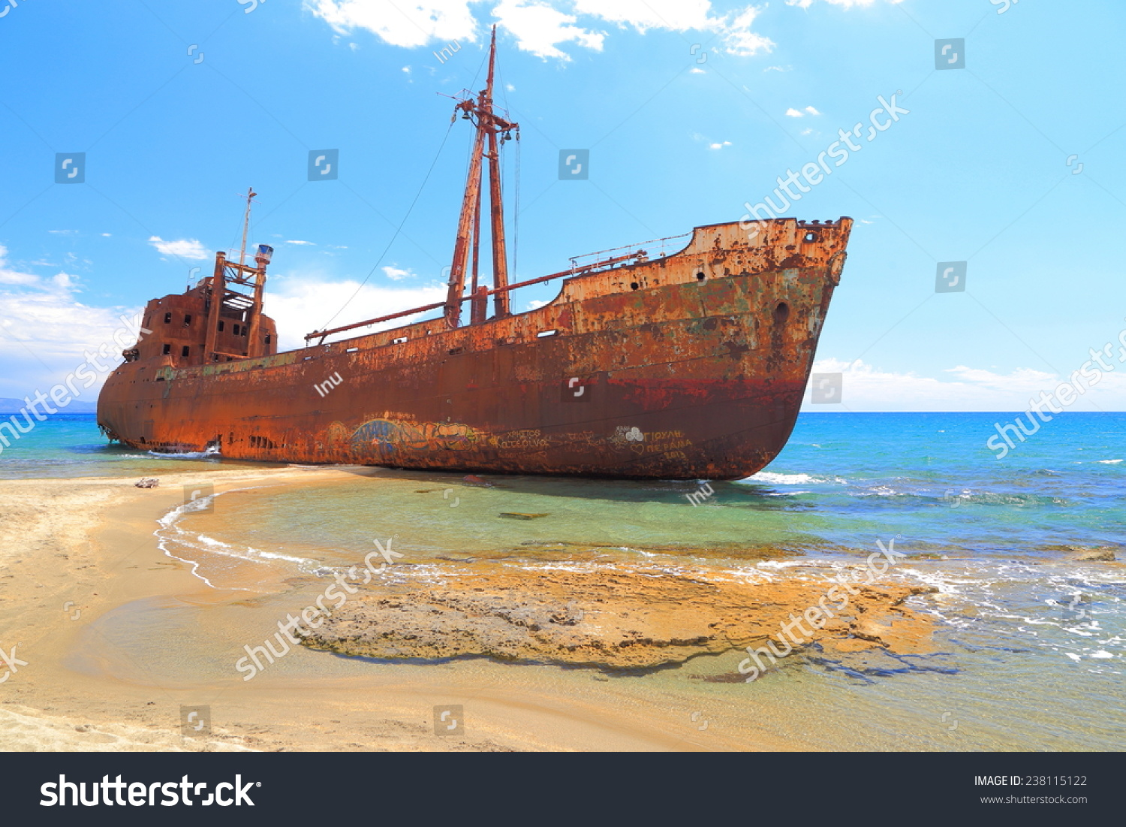

## flowchart

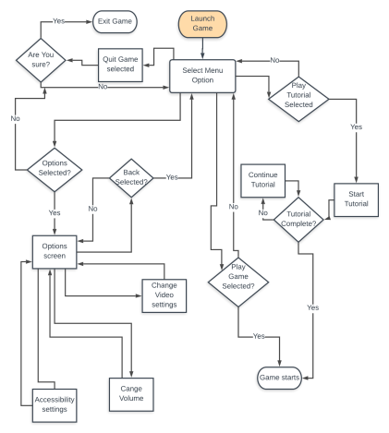

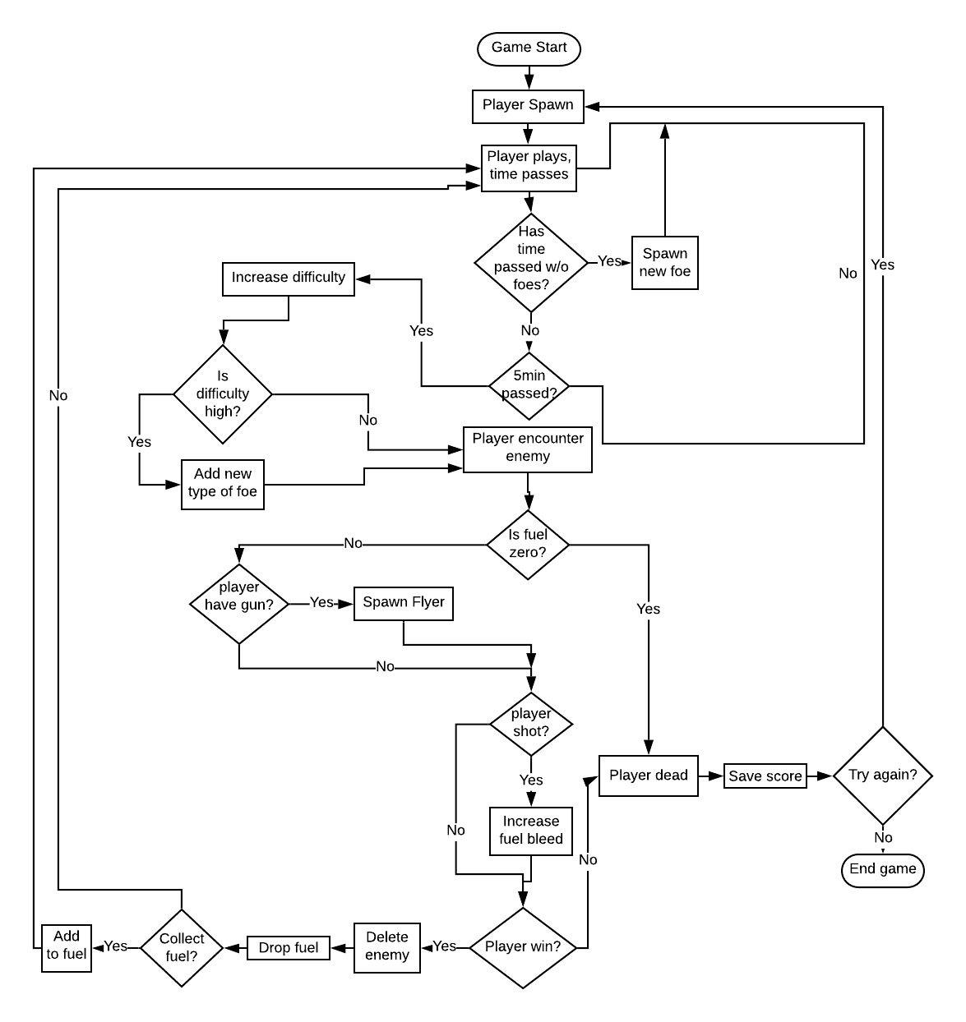

# Interface

## Menu

The main menu of the game will show the player four options: Play, Tutorial, Options and Quit. The menu’s background will feature an infinite scroll with the game’s logo and menu buttons fixed in place.

## Hud

The heads-up display will contain a score counter, a fuel tank, whatever weapon the player is holding and a hazard light symbol – the hazard light will flicker and slowly become more and more red as time passes and the threat the player faces becomes too much to handle.

## camera

The camera will be centred on the players car and follow them as the traverse the arena. It will be set at an angle to show the 3d models but not so much the player can see the sky.

# Team

Andrew Scott – Programmer, coordinator

Tembani Mdaya – Lead artist, composer

Thomas Riches – Programmer, designer

# Appendices

## asset list